JOB – PORTAL
Laravel – PHP
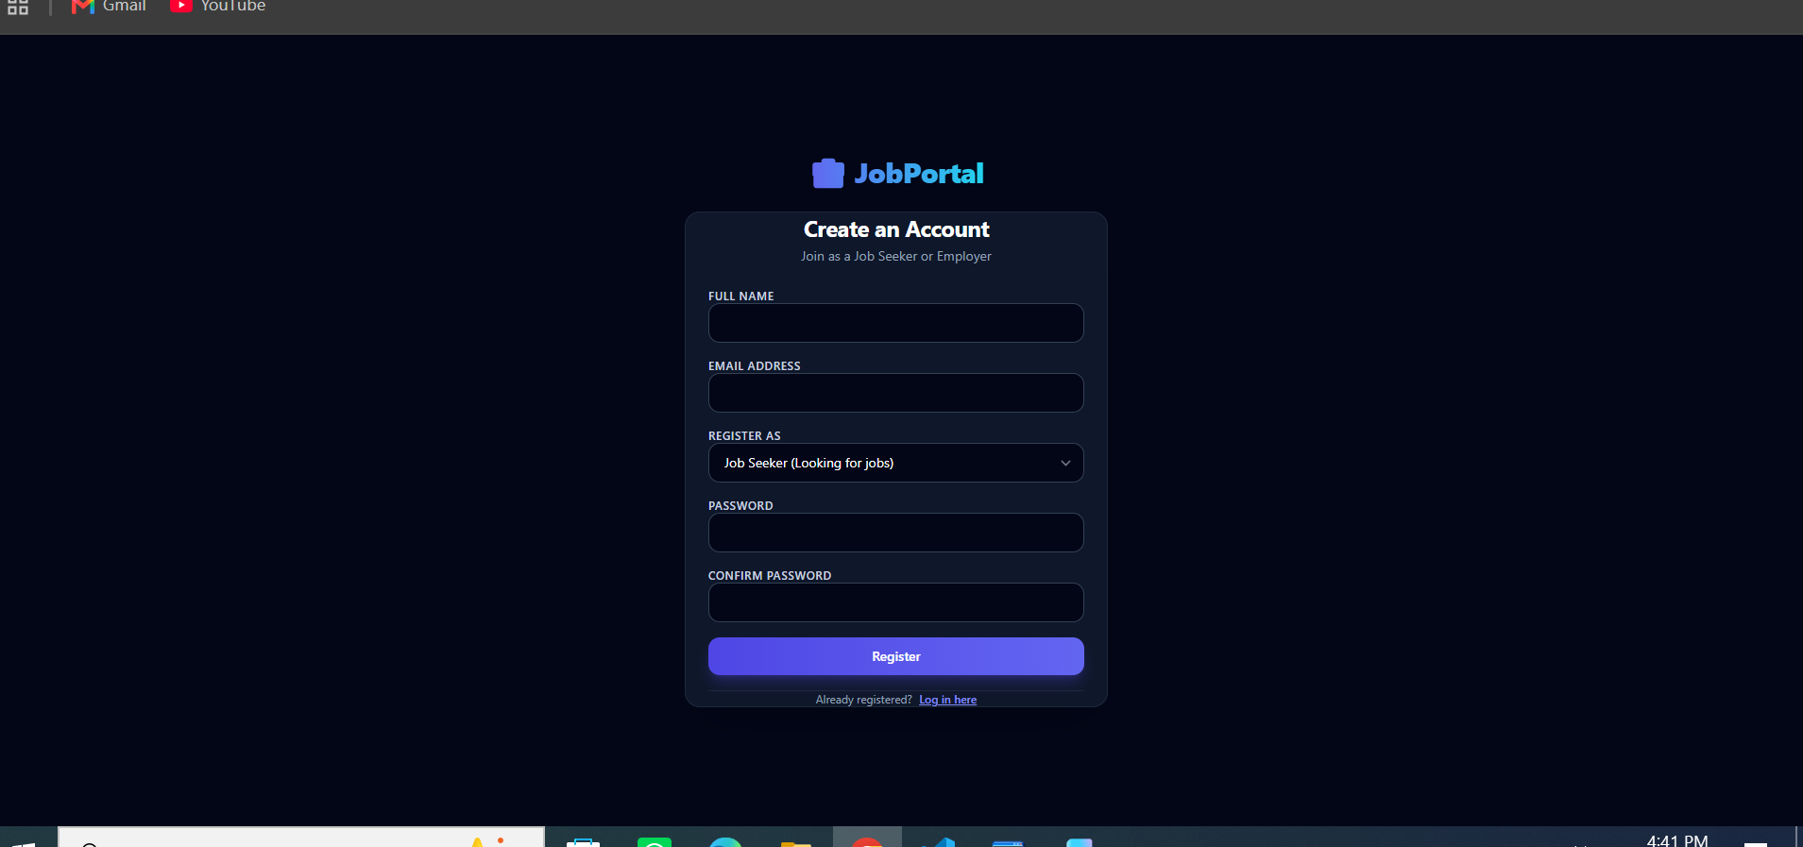
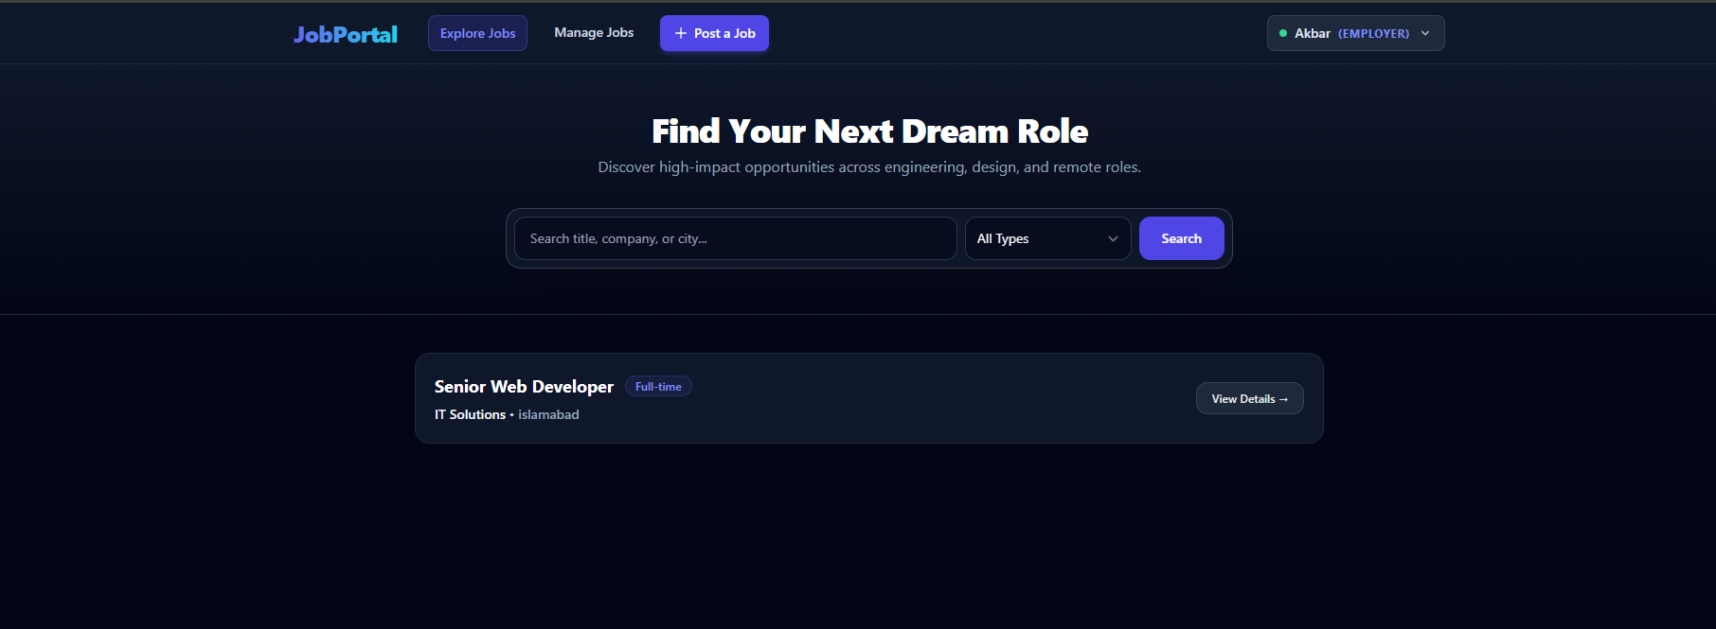
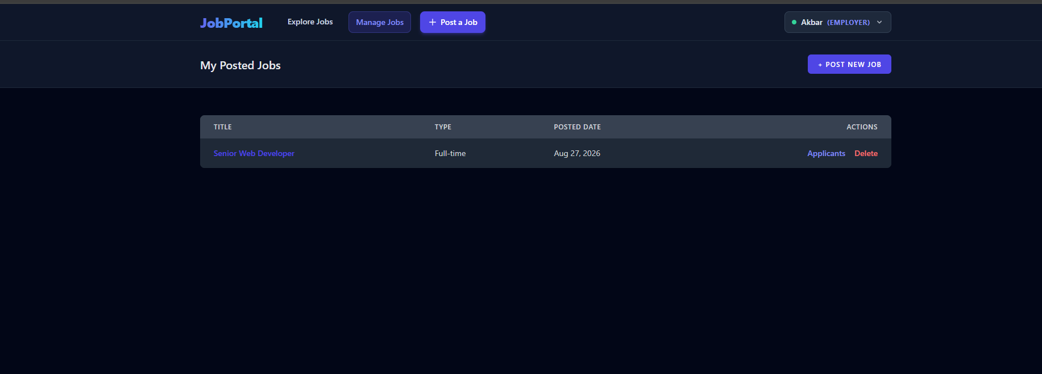
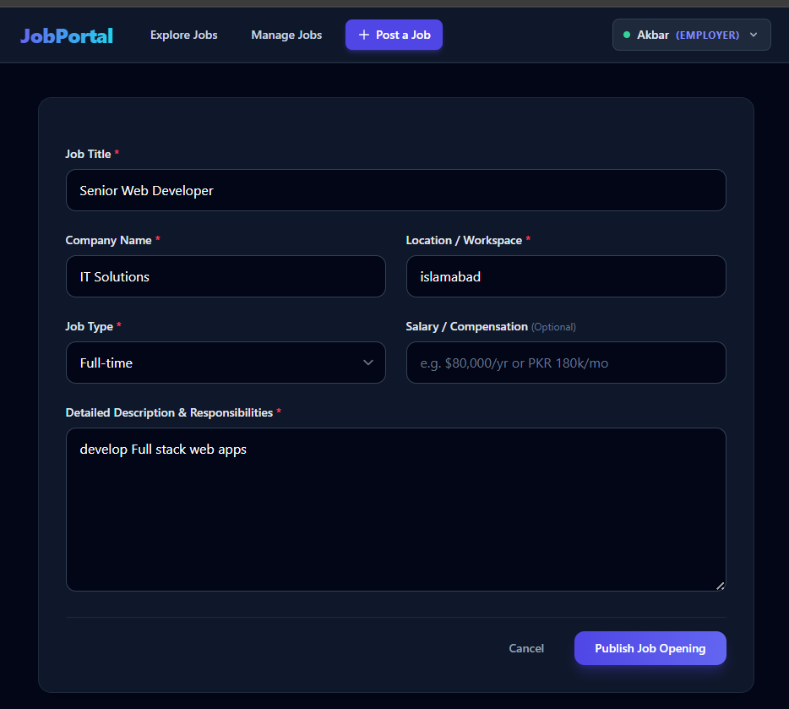
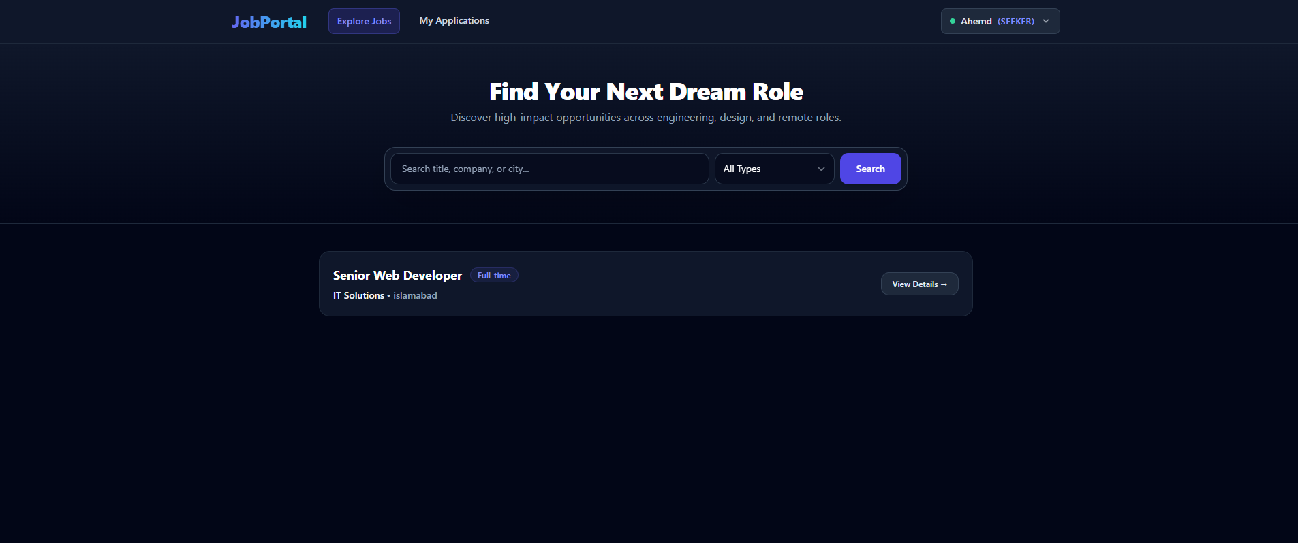
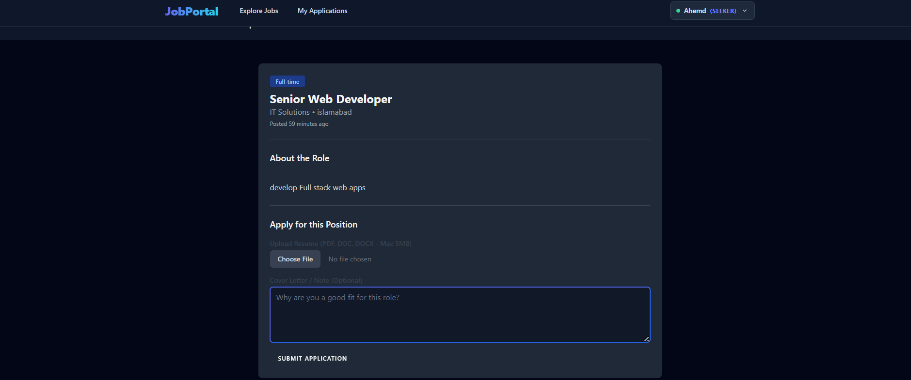
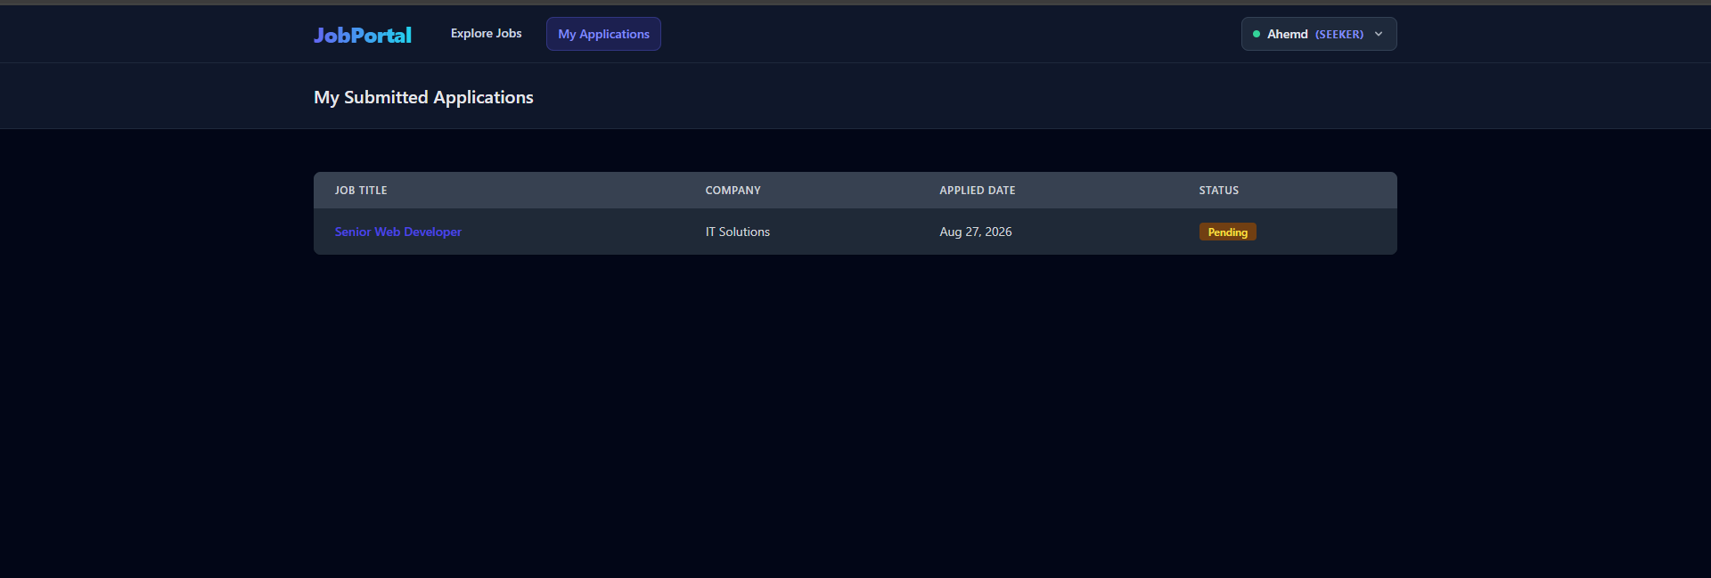
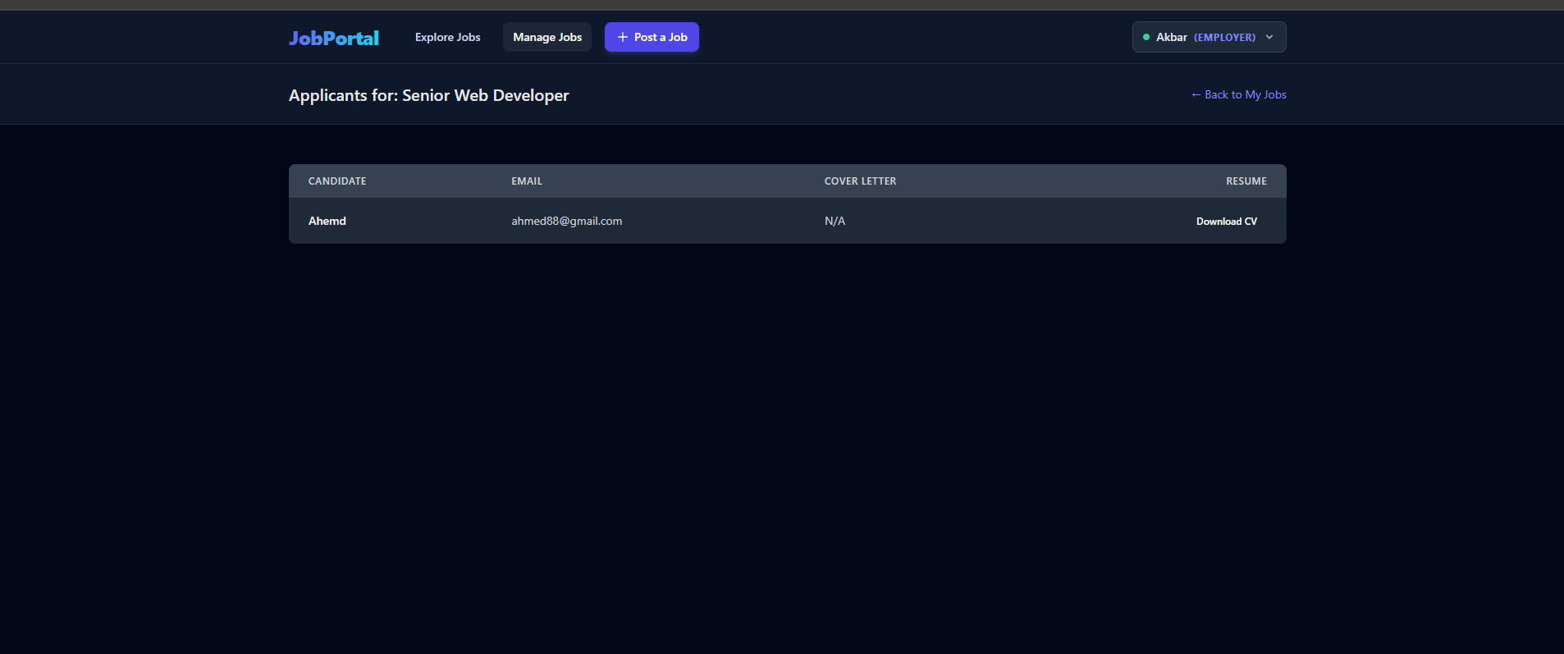
In your open MySQL 8.0 Command Line Client window, run these commands one by one:
- Select your database:
SQL
USE job_portal;
- List all tables:
SQL
SHOW TABLES;
- View stored users:
SQL
SELECT * FROM users;
- View posted jobs:
SQL
SELECT * FROM job_posts;
- View submitted applications:
SQL
SELECT * FROM job_applications;
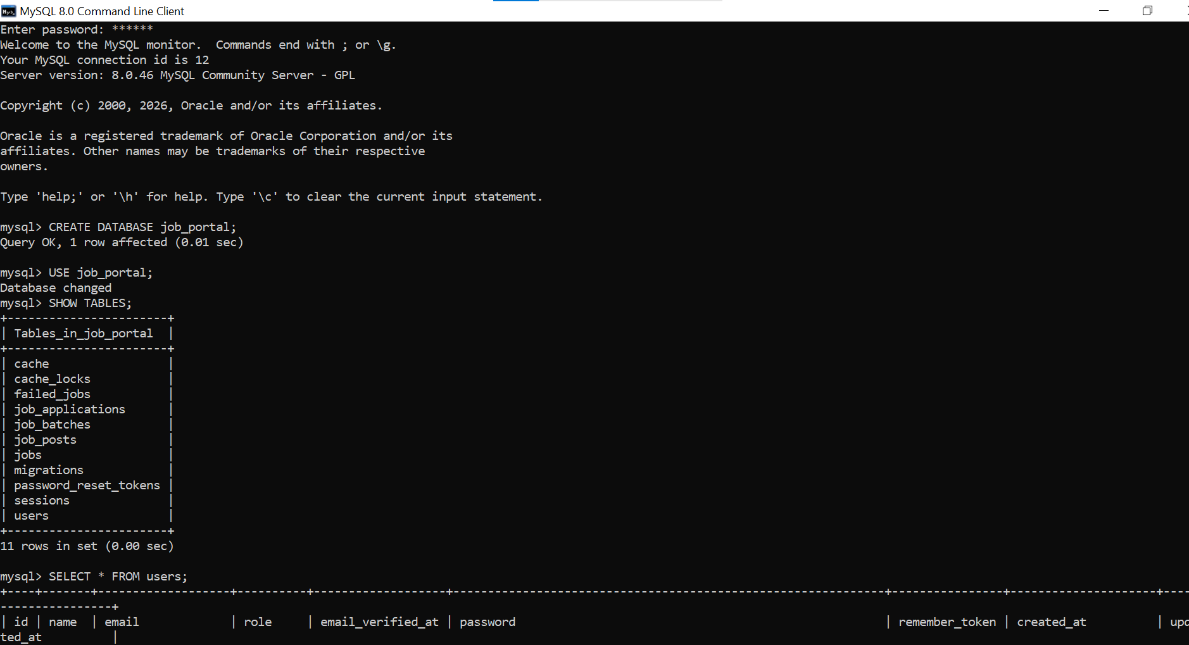
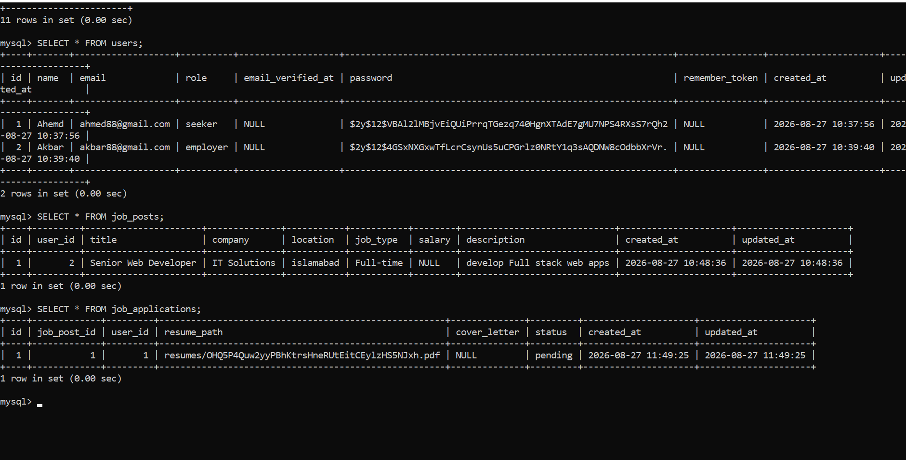
Recrutier :
akbar88@gmail.com
11223344
Job Seeker :
ahmed88@gmail.com
11223344
